Manuscript Title (Times New Roman, 14 pt, Bold, Centered)
Insert the full title here. Use Title Case, avoid abbreviations, and keep the length concise and informative. Leave one blank line before and after the title.

Author Name¹, Author Name², Author Name³ (Times New Roman, 12 pt, Bold, Centered)
¹Affiliation for Author 1: Department, Institution, City, Country (Times New Roman, 11 pt, Centered)
²Affiliation for Author 2: Department, Institution, City, Country
³Affiliation for Author 3: Department, Institution, City, Country
Corresponding author line should be written here, for example:
Corresponding author: email@domain.com (Times New Roman, 10 pt, Centered).

Abstract formatting: The abstract should provide a concise summary of the research, including background, aim, methodology, main results, and conclusions. Use Times New Roman, 11 pt, fully justified, with 1.0–1.15 line spacing inside the abstract block. Do not indent the first line of the abstract. The recommended length is approximately 150–250 words. Avoid references, figures, or equations in the abstract.
Keywords: Provide 4–6 keywords here, separated by commas. Use Times New Roman, 11 pt, regular, left aligned. The label “Keywords:” must be in bold, followed by a single space and the list of keywords in sentence case (e.g., intelligent transport system, 5G network, V2I, smart city).
Submitted on: DD Month YYYY Accepted on: DD Month YYYY Published on: DD Month YYYY

1. INTRODUCTION
Section headings must be numbered (1, 2, 3, …), left aligned, in Times New Roman, 11 pt, bold, and uppercase. Main body text should be in Times New Roman, 11 pt, with 1.5 line spacing, fully justified. The first line of each paragraph should be indented by about 0.5 cm.
In the Introduction, authors should explain the background, motivation, research gap, and objectives of the work, supported by relevant citations. Use author-based in-text citations, for example: “SampleAuthor et al. (2024) demonstrated that …” or “Recent studies on intelligent transport systems (ExampleAuthor & CoAuthor, 2023) indicate that …”. When citing multiple sources together, use: “Several works (SampleAuthor et al., 2024; ExampleAuthor & CoAuthor, 2023) have reported …”.

2. LITERATURE REVIEW
This section summarises the existing work relevant to the topic. Use the same body text style as the Introduction (Times New Roman, 11 pt, 1.5 line spacing, justified). Organise the literature logically (e.g., by topic, method, or chronology).
Highlight the limitations in existing studies that your work aims to address. Example: “While BaselineAuthor et al. (2020) propose a generic framework, their model does not consider real-time 5G integration. Similarly, ReviewAuthor (2021) provides a broad overview but does not include V2I-specific case studies.”

3. INTELLIGENT URBAN TRAFFIC MANAGEMENT SYSTEM
This section typically describes the proposed system or framework in detail. You may divide it into subsections such as architecture, components, data flow, and algorithms. Use numbered subsections when needed, and cross-reference figures and tables appropriately (e.g., “as shown in Figure 1” or “see Table 1”).

3.1 5G-Enabled Vehicle-to-Infrastructure (V2I) Communication Framework
Subsection headings must be in Times New Roman, 11 pt, bold, left aligned, and numbered as 3.1, 3.2, etc. The text inside subsections follows the same format as the main body text (11 pt, justified, 1.5 line spacing).
In this subsection, describe system modules, interfaces, communication protocols, and assumptions. Refer to prior frameworks or standards using author-based citations, for example: “A comparable V2I architecture is outlined by FrameworkAuthor et al. (2022).”

4. SIMULATION ENVIRONMENT AND PERFORMANCE ANALYSIS
In this section, provide details of the experimental or simulation setup and present the performance evaluation. Include descriptions of tools, datasets, parameters, and evaluation metrics. Tables and figures must be numbered and referred to in the text (e.g., “Figure 1 shows…” , “Table 1 summarises…”).
Example sentence: “The simulation environment is configured following the parameters adopted by ModelAuthor and CoAuthor (2023), with modifications to accommodate 5G-specific latency constraints.”

4.1 Simulation Setup
Describe the environment configuration (e.g., software, hardware, network parameters), scenarios, and comparison baselines. Ensure that all variables and units are clearly defined. Use concise, technical language, and cite any standard benchmarks or tools used in the setup, for instance: “The traffic scenarios are adapted from BenchmarkAuthor et al. (2022).”

4.2 Sample Figure Formatting
Figures must be clear, legible, and of high resolution. Use vector formats such as PDF or EPS when possible. All figures should be numbered consecutively (Figure 1, Figure 2, etc.) in the order in which they appear in the text and must be cited before or immediately after they are introduced. Figure captions should be placed below the figure, in Times New Roman, 10–11 pt, with a brief and informative description.
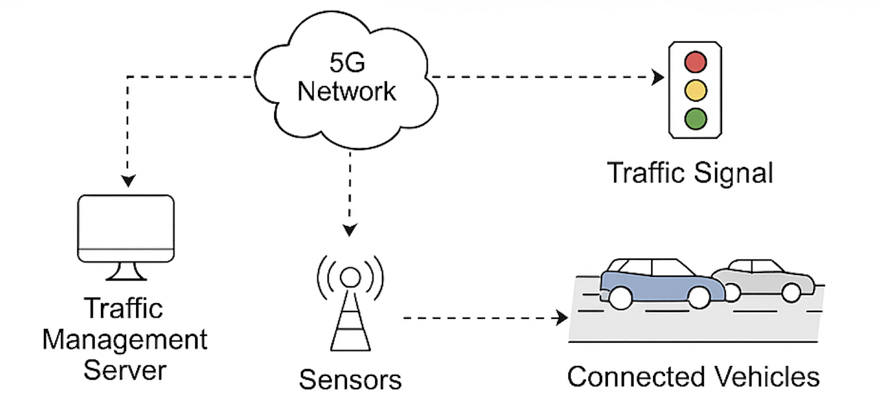
Figure 1. Sample figure showing the overall V2I-based intelligent traffic management architecture. Authors should replace this placeholder with their actual system-level diagram and ensure all text labels in the figure are clearly readable.
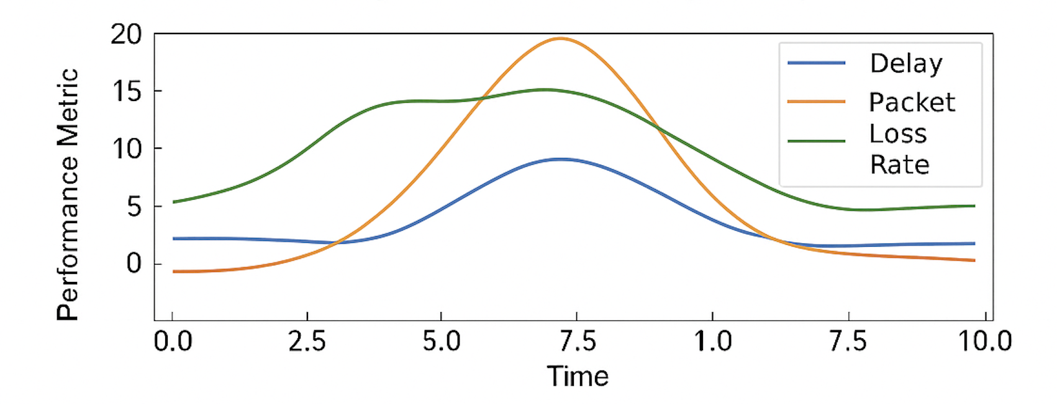
Figure 2. Sample performance plot illustrating throughput or delay comparison under different traffic densities. Authors should use consistent axis labels, units, and legends, and avoid excessive visual clutter.
In the text, refer to the figures as “Figure 1” and “Figure 2” rather than using expressions like “the above figure” or “the following figure”.

4.3 Sample Table Formatting
Tables should be used to present structured numerical or categorical information. Each table must be numbered consecutively (Table 1, Table 2, etc.) in the order of appearance and must be cited in the text. Captions for tables must be placed above the table, in Times New Roman, 10–11 pt, and clearly describe the content. Avoid vertical rules and minimise the use of horizontal rules to keep tables visually clean.
Table 1. Sample simulation parameters for the 5G-enabled V2I environment.
Parameter | Value
Carrier frequency | 3.5 GHz
Channel bandwidth | 100 MHz
Transmission power | 30 dBm
Cell radius | 500 m
Vehicle speed range | 0–80 km/h
Simulation duration | 600 s

Table 2. Sample performance metrics obtained from the proposed framework and baseline models.
Scenario | Proposed | Baseline A | Baseline B
Average delay (ms) | 18.5 | 27.3 | 31.0
Packet delivery ratio (%) | 98.2 | 94.6 | 92.1
Throughput (Mbps) | 85.4 | 72.8 | 69.5
When discussing tables, use references such as “Table 1 lists the main simulation parameters” and “Table 2 summarises the performance metrics for different models”.

5. CONCLUSION
The Conclusion section should briefly restate the problem addressed, summarise the main contributions and findings, and highlight possible future work. Avoid repeating large portions of text from previous sections. Example: “In contrast to earlier approaches (BaselineAuthor et al., 2020), the proposed framework integrates real-time 5G-based V2I communication and demonstrates improved performance under dense urban traffic conditions.”

REFERENCES
References must be listed in the order in which they are first cited in the text (not alphabetically). Use Times New Roman, 10 or 11 pt, single line spacing, with a hanging indent (first line flush left, subsequent lines slightly indented). Use an author–year style in the reference list as well. Number the references as [1], [2], [3], … using square brackets. Below are sample placeholder references illustrating the required style. Authors must replace them with actual references relevant to their manuscript.
[1] BaselineAuthor, A., & CoAuthor, B. (2020). Example article title in sentence case for intelligent transport systems. Sample Journal of Transportation Engineering, 12(3), 123–135.
[2] ReviewAuthor, C. (2021). Example survey title on urban traffic management. Sample Review Journal, 8(1), 10–40.
[3] FrameworkAuthor, D., ExampleAuthor, E., & HelperAuthor, F. (2022). Example framework title for 5G-enabled V2I communication. In Proceedings of the Sample International Conference on Smart Cities (pp. 45–52). Sample City, Sample Country.
[4] ModelAuthor, G., & CoAuthor, H. (2023). Example model title for simulation-based traffic analysis. Sample Transactions on Systems, 5(2), 200–210.
[5] BenchmarkAuthor, I., TestAuthor, J., & DemoAuthor, K. (2022). Example benchmark dataset for vehicular simulations. Sample Data and Simulation Journal, 4(4), 300–320.
Ensure that every work cited in the text appears in this list and that the sequence of references [1], [2], [3], … matches the order of first citation in the manuscript.

